



BMI: Body Mass Index
MANAGEMENT PROGRAM

A program that calculates your BMI and tells you based on your results what can be the future problems you can face. It also makes your database and shows average BMI as per the previous users.




Vasu Aggarwal
19103151
B5
Table of Contents

- Features
- Header files and their use
- Pre-defined functions used
- User defined functions and classes
- Coding
- Outputs
- Requirements
- Bibliography

Features
- It calculates your BMI and gives you list of potential health related issues you can face in your near future.
- It shows you an average BMI based on our previous users just like you, so that you can get a brief idea of where you stand in the crowd.
- If you are one of our previous users then you can search for your previous record easily from our database.

Header Files and their uses
- Fstream: for file handling
- unistd.h: for usleep(int) function to stop the execution of program
- Vector: for using vector (dynamic array like structure) class of C++STL
- Iostream: for handling input output operations
- cstring.h: for strcmp(char*,char*) function to compare strings

Pre-defined functions used

- system(“clear”): clears the console window (functions same as clrscr() defined in conio.h)

- usleep(x): pauses the execution of program for ‘x’ milliseconds(functions same as delay(x) defined in conio.h)

- ary.clear(): clears the contents of the ‘ary’(vector array)

- ary.push_back(x): adds ‘x’ to the end of ‘ary’

User defined functions and classes

- class user :
  - public members:
    - int – age, sno
    - float – height, weight, bmi, inch, foot
    - char – sex, name, result
    - func – getdata()
  - getdata(): takes all the necessary information from the user, stores it in the variables and calculates the BMI
- class file :
  - writes all the necessary information including results in “report.txt” which can be directly printed
  - objects : print(defined in function display(user&currentuser))
- class console :
  - displays user’s results based on user’s calculated BMI to the console window
  - objects : terminal(defined in function display(user&currentuser))
- gotoxy(int x , int y):
  - shifts the output pointer to the specified location (x,y)
  - originally defined in conio.h but here copied from GitHub
- intro():
  - shows an animation using primitive printing techniques and loops displaying the name of the program “BMI_MANAGEMENT_PROGRAM”
- display(user &currentuser):
  - display user’s results based on calculated BMI
  - calls the functions in classes console and file based on the result determined by specified criteria
- calcavgbmi():
  - reads all the records from “database.dat” and saves them in ‘ary’
  - calculates the average BMI of all the database records
- newuser():
  - makes a new record for the new user and saves the new record in “database.dat”
- displayrec(int no):
  - prints the sno and name for the record ‘no’ from the vector ‘ary’
- existinguser():
  - searches from the database on the basis of name or age for a previous user’s record and if found display all its information
- information():
  - prints all the information about the program with its features

Coding
#include <fstream>
#include <vector>
#include <iostream>
#include <unistd.h>
#include <cstring>

using namespace std;

float avgbmi,lastsno=0;
int c;

class user
{
public:
int age,sno;
float height,weight,bmi=0,inch,foot;
char sex,name[30],result[8];
void getdata();

};

void gotoxy(int x,int y)
{
printf("%c[%d;%df",0x1B,y,x);
}

void intro()
{
system("clear");
string str = "BMI_MANAGEMENT_PROGRAM";
for(int a=0 ; a<22 ; a++)
{

for(int i=0 ; i<11 ; i++)
{
gotoxy(20+a,i);
cout<<str[a];
usleep(6500 - 500*i);
if(i<10)
{
cout<<"\b\b"<<" ";
}
}
}
cout<<"\n\n\n\n\n ";
cout<<"\n\nPress any key to continue...";
int wait = getchar();
}

void information()
{
cout<<"\t\t\tBMI_MANAGEMENT_PROGRAM\n\n";
cout<<"Salient features of the program :\n\n";
cout<<"1\tIt calculates your BMI and gives you list of probable threats you could\n\tface if you will not give you health a good thought\n";
cout<<"\n2\tIt shows you an average BMI based on our previous users just like you, \n\tso that you can get a brief idea of where you stand in the crowd\n\n";
cout<<"3\tIf you are one of our previous users then you can search for your \n\tprevious record easily from our database\n\n\n\t\t";
cout<<"\n\nPress any key to continue...";
int wait = getchar();
}

vector<user> ary;

class file
{
private:
ofstream rep;
public:
file(user &currentuser)
{
rep.open("Report.txt");
rep<<"\tBMI REPORT\n\nName : "<<currentuser.name<<"\nAge : "<<currentuser.age<<" yrs\nSex : "<<((currentuser.sex=='f')?"Female":"Male")<<"\nHeight : "<<currentuser.foot<<" feet "<<currentuser.inch<<" inches\nWeight : "<<currentuser.weight<<" kg\nBMI : "<<currentuser.bmi<<"\n\n";
}

void chigh(char abc[15])
{
rep<<"You are "<<abc<<endl;
rep<<"\nCONSEQUENCES:\nThere is risk of cardiovascular diseases\n80% chance of staying obese\nType 2 Diabetes\nAsthama\nsleep Apnea\nPsychological Stress\nLow Self Esteem";
}

void ahigh(char abc[15])
{
rep<<"You are "<<abc<<endl;
rep<<"\nCONSEQUENCES:\nHyper Tension\nDyslipidemia\ntype 2 Diabetes\nCoronary Heart Diseases\nStroke\nGall Bladder Disease\nOsteoarthritis\nsleep Apnea\nRespiratory Problems\nSome CANCERS(endometrial, breast, colon)";
}

void clow(char abc[15])
{
rep<<"You are "<<abc<<endl;
rep<<"\nCONSEQUENCES:\nDelayed Growth and Development\nFragile Bones\nWeakened Imune System\nAnemia";
}

void alow(char abc[15])
{
rep<<"You are "<<abc<<endl;
rep<<"\nCONSEQUENCES:\nFragile Bones\nWeakened Imune System\nAnemia\nFertility Issues\nHair Loss";
}

void healthy()
{
rep<<"You are in healthy BMI range\n\nYOU COULD ESCAPE FROM MANY DISEASES EASILY JUST KEEP IT UP!";
}

~file()
{
rep.close();
}
};

class console
{
public:
void chigh(char abc[15])
{
cout<<"\nYou are "<<abc<<endl;
cout<<"\nCONSEQUENCES:\nThere is risk of cardiovascular diseases\n80% chance of staying obese\nType 2 Diabetes\nAsthama\nsleep Apnea\nPsychological Stress\nLow Self Esteem";
}

void ahigh(char abc[15])
{
cout<<"\nYou are "<<abc<<endl;
cout<<"\nCONSEQUENCES:\nHyper Tension\nDyslipidemia\ntype 2 Diabetes\nCoronary Heart Diseases\nStroke\nGall Bladder Disease\nOsteoarthritis\nsleep Apnea\nRespiratory Problems\nSome CANCERS(endometrial, breast, colon)";
}

void clow(char abc[15])
{
cout<<"\nYou are "<<abc<<endl;
cout<<"\nCONSEQUENCES:\nDelayed Growth and Development\nFragile Bones\nWeakened Imune System\nAnemia";
}

void alow(char abc[15])
{
cout<<"\nYou are "<<abc<<endl;
cout<<"\nCONSEQUENCES:\nFragile Bones\nWeakened Imune System\nAnemia\nFertility Issues\nHair Loss";
}

void healthy()
{
cout<<"\nYou are in healthy BMI range\n\nYOU COULD ESCAPE FROM MANY DISEASES EASILY JUST KEEP IT UP!";
}
};

void display(user &currentuser)
{
cout<<"\n\nThe average BMI is: "<<avgbmi<<"\nYour bmi is :"<<currentuser.bmi;
file print(currentuser);
console terminal;
if(currentuser.age>20)
{
if(currentuser.bmi<=18.5)
{
terminal.alow("Underweight");
print.alow("Underweight");
}
else if(currentuser.bmi>18.5 && currentuser.bmi<=25)
{
terminal.healthy();
print.healthy();
}
else if(currentuser.bmi>25 && currentuser.bmi<=30)
{
terminal.ahigh("Overweight");
print.ahigh("Overweight");
}
else if(currentuser.bmi>20 && currentuser.bmi<=35)
{
terminal.ahigh("Obese");
print.ahigh("Obese");
}
else if(currentuser.bmi>35)
{
terminal.ahigh("Severely Obese");
print.ahigh("Severely Obese");
}
}
else if(currentuser.age<20 && currentuser.age>=2)
{
if(currentuser.bmi<=18.5)
{
terminal.clow("Underweight");
print.clow("Underweight");
}
else if(currentuser.bmi>18.5 && currentuser.bmi<=25)
{
terminal.healthy();
print.healthy();
}
else if(currentuser.bmi>25 && currentuser.bmi<=30)
{
terminal.chigh("Overweight");
print.chigh("Overweight");
}
else if(currentuser.bmi>20 && currentuser.bmi<=35)
{
terminal.chigh("Obese");
print.chigh("Obese");
}
else if(currentuser.bmi>35)
{
terminal.chigh("Severely Obese");
print.chigh("Severely Obese");
}
}

}

void calcavgbmi()
{
float sumbmi=0;
user temp;
ary.clear();
ifstream obj("Database.dat",ios::binary);
while(obj.read((char*)&temp,sizeof(temp)))
{
lastsno=temp.sno;
ary.push_back(temp);
sumbmi+=temp.bmi;
}
if(lastsno==0)avgbmi=0;
else avgbmi=sumbmi/lastsno;
obj.close();
}

void newuser()
{
user cuser;
cuser.getdata();
ofstream obj;
if(lastsno!=0)
obj.open("Database.dat",ios::binary|ios::app);
else obj.open("Database.dat",ios::binary);
obj.write((char*)&cuser,sizeof(cuser));
display(cuser);
}

void displayrec(int no)
{
cout<<ary[no].sno<<"\t"<<ary[no].name<<"\n";
}

void existinguser()
{
int age=0,usersno=-1,choice;
char name[20];
cout<<"Do you want to find yourself by your name or your age. Press \n[1] for age \n[2] for name\n------> ";
cin>>choice;
do
{
if(choice==1)
{
cout<<"Enter your age? ";
cin>>age;
cout<<"\n Following is the list of records for the specified age.\n\nSNo\t Name\n";
for(int i=0 ; i<ary.size() ; i++)
{
if(ary[i].age==age)displayrec(i);
}
break;
}
else if (choice == 2)
{
cout<<"Enter your first name : ";
cin>>name;
cout<<"\n Following is the list of records for the specified name.\n\nSNo\t Name\n";
for(int i=0 ; i<ary.size() ; i++)
{
if(strcmp(ary[i].name,name)==0)displayrec(i);
}
break;
}
else
{
cout<<"Wrong choice. Re-enter : ";
cin>>choice;
}
}
while(1);
cout<<"\nEnter the SNo for your entry and if it is not in the list then press 0\n\t: ";
cin>>usersno;
while(usersno>ary.size())
{
cout<<"Invalid SNo entered\nPlease re-enter: ";
cin>>usersno;
}
if(usersno==0)cout<<"Sorry your record does not exist in our database.";
else
{
display(ary[usersno-1]);
}
}

int main()
{
char con;
intro();
system("clear");
information();
do
{
system("clear");
calcavgbmi();
int choice;
cout<<"\n\t\tBMI Management Program\n\nWhat do you want to do??\n\n 1\tFor new entry\n 2\tFor searching previous entries\n\nEnter: ";
cin>>choice;
switch(choice)
{
case 1:
newuser();
break;
case 2:
existinguser();
break;
}
cout<<endl<<endl;
while ((c = getchar()) != '\n' && c != EOF);
cout<<"\n\nPress any key to continue...";
int wait = getchar();
system("clear");
cout<<"\nDo you want to continue? <y/n> ";
cin>>con;
}
while(con=='y'||con=='Y');

return 0;
}

void user::getdata()
{
system("clear");
cout<<"\n\t\t\tBMI REPORT\n\n";
while ((c = getchar()) != '\n' && c != EOF);
cout<<"Enter Your name: ";
cin.getline(name,30);
//while ((c = getchar()) != '\n' && c != EOF);
cout<<"Enter your age: ";
cin>>age;
cout<<"Enter your sex<m/f>: ";
cin>>sex;
cout<<"Enter your Height : \n\tFeet : ";
cin>>foot;
cout<<"\tInches : ";
cin>>inch;
cout<<"Enter your weight(kg): ";
cin>>weight;
height=2.6*(inch+(12*foot));
name[0]=toupper(name[0]);
bmi=weight/(height*height/10000);
sno=++lastsno;
}

Outputs
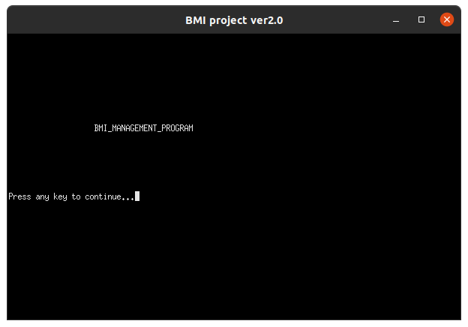

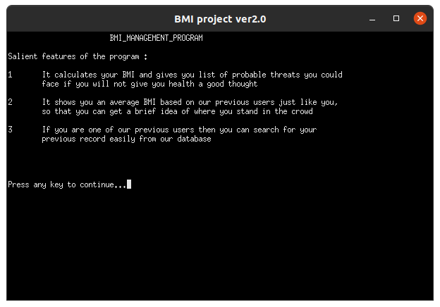

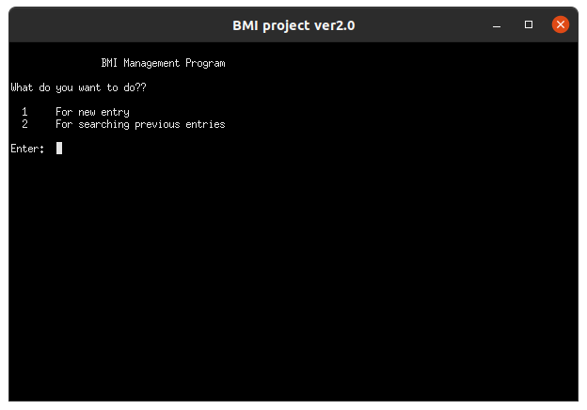

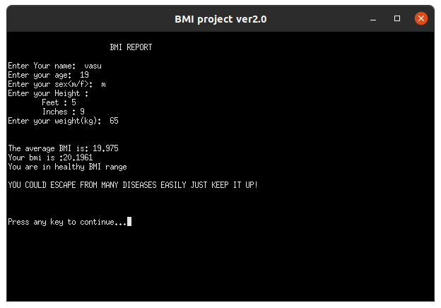

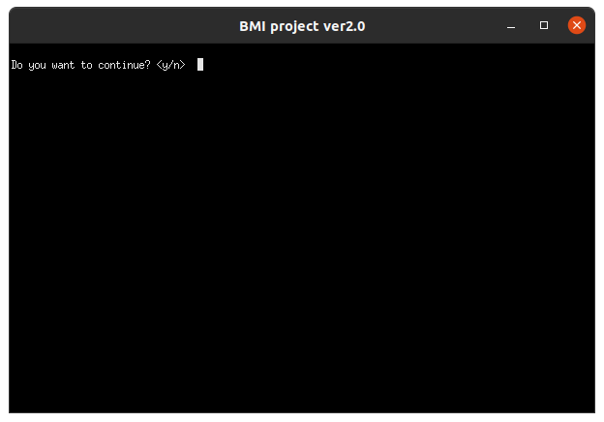

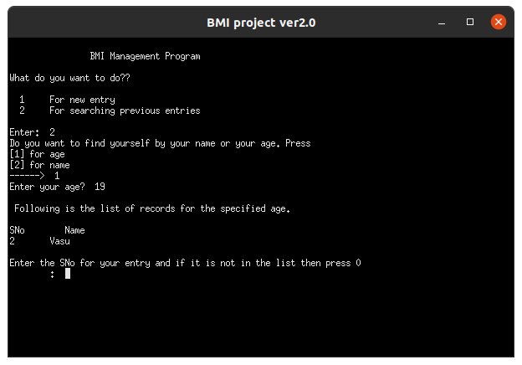

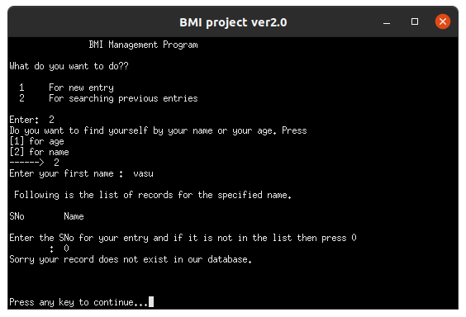

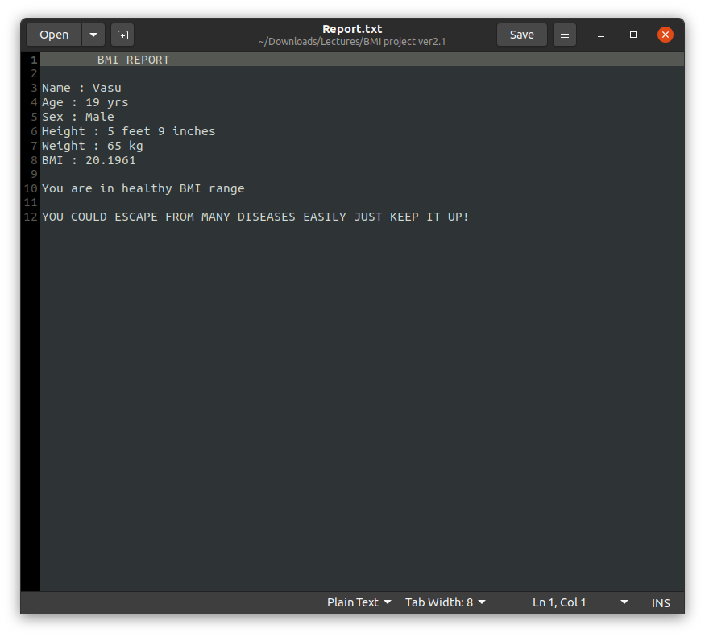

Requirements

- Hardware Required

- Printer, to print the required documents of the project
- Compact Drive
- Processor: Pentium III
- Ram: 64 MB
- Hard disk: 20 Gb.

- software Required

- Operating system: Linux
- Code::Blocks 16.0x for execution of program
- MS word, for presentation of output
- Compiler: GCC for Linux

Bibliography

- Computer Science in C++ by Sumita Arora
- Stack Overflow
- GeekforGeeks
- GitHub
- Other online references

